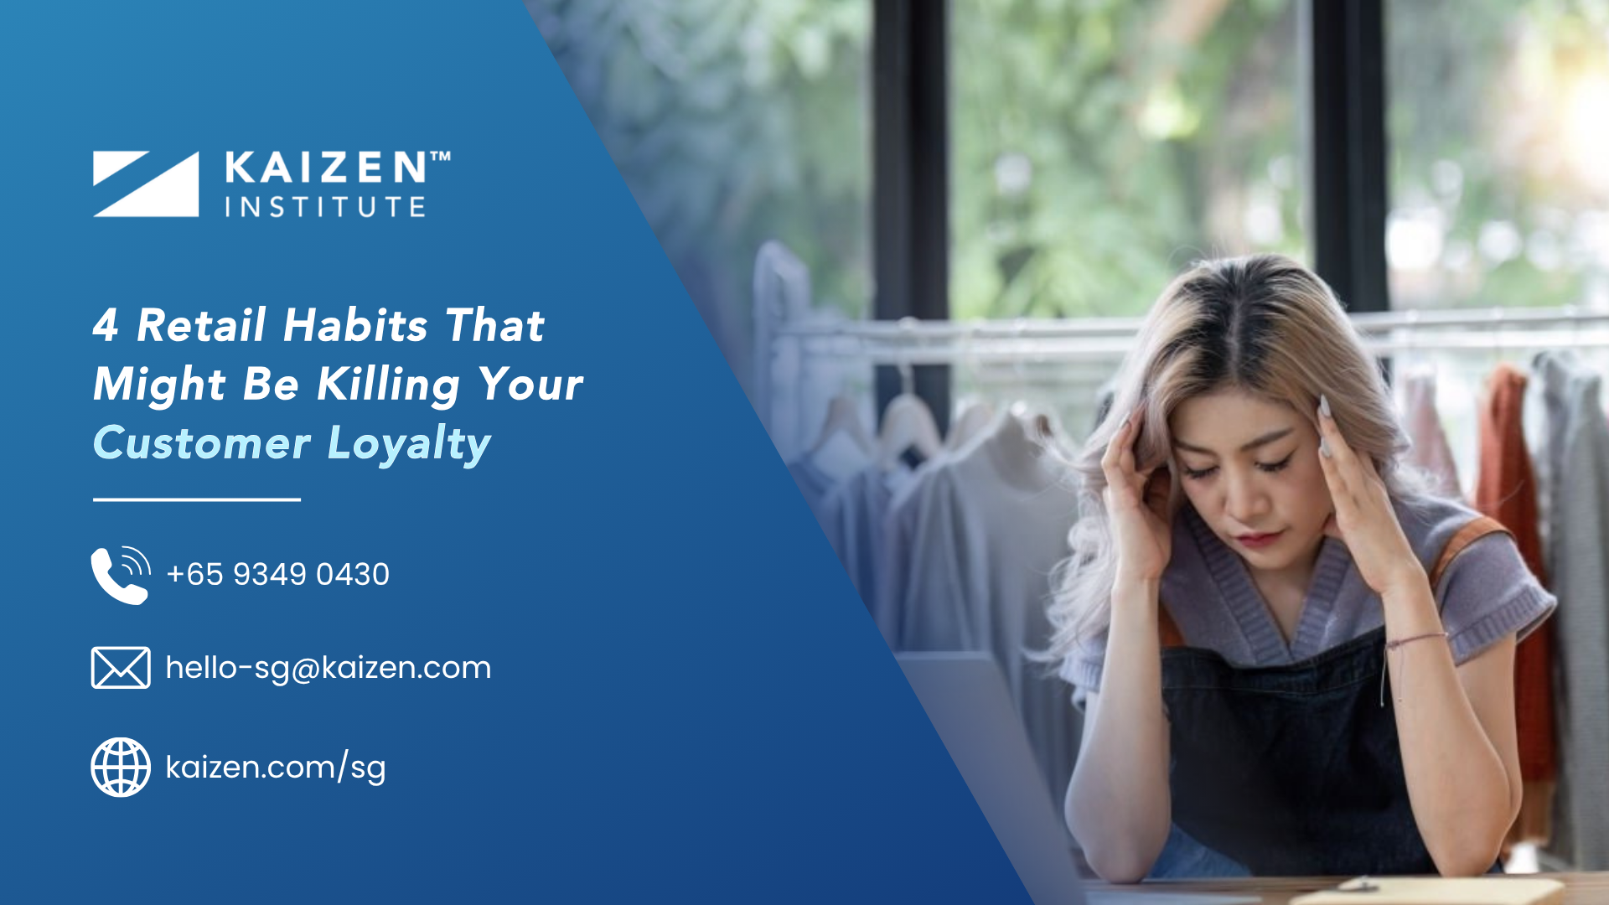**🧠 Why Customers Aren’t Coming Back**

**Rethinking Loyalty and In-Store Experience in Singapore Retail**

Singapore’s retail scene is known for its vibrancy and innovation. From luxury malls to neighbourhood heartland stores, we’ve built one of the most diverse retail landscapes in the region.

But today, many retailers are grappling with a difficult truth: footfall has returned, but repeat purchases are not.

Loyalty programs aren’t sticking. Promotions generate clicks, but they don’t convert into long-term relationships. So, what’s really going on?

At Kaizen Institute, we work with retailers across Asia to uncover the operational and behavioural blind spots that quietly erode customer loyalty. One thing is clear.

Loyalty today is no longer just a marketing initiative. It is an outcome of consistent operations, meaningful experiences, and a customer-focused culture.

This article explores the real reasons why customers stop coming back and how to rethink loyalty through the KAIZEN™ approach.



**❌ Symptom 1: Loyalty Cards, But No Loyalty**

You may already have a rewards program. But if customers aren’t returning, it’s time to ask yourself:

* Is it truly personalised, or just a points system?
* Does it work across all customer touchpoints, including online and in-store?
* Are you rewarding customer engagement, or just the transaction?

Many loyalty schemes are designed around transactions, not relationships. Today’s customers, especially millennials and Gen Z, are looking for something more. They want relevance, recognition, and connection.

**✅ The KAIZEN™ Fix**

* Replace generic promotions with personalised offers based on actual customer behaviour.
* Rethink loyalty tiers to reflect frequency, diversity of purchases, and participation in feedback or referral programs.
* Reward meaningful engagement, such as product reviews, in-store surveys, or social referrals.

**❌ Symptom 2: Inconsistent Experience Across Channels**

Modern shoppers might browse a product on Instagram, purchase it in-store, and request a return via your app. If those touchpoints feel disconnected, trust is easily broken.

In our work with retailers in Singapore, we’ve seen common issues like:

* Online promotions not being honoured in physical stores.
* Loyalty points that work on an app but can't be redeemed at the cashier.
* Service quality that varies drastically across locations.

These small breaks in the customer journey create frustration and damage brand credibility.

**✅ The KAIZEN™ Fix**

* Conduct a SIPOC analysis to visualise your omnichannel customer journey and spot disconnects.
* Align backend systems so customer data, promotions, and support can flow seamlessly between channels.
* Train your frontline teams to see the store as part of a larger ecosystem, not just a point-of-sale.

**❌ Symptom 3: Stores That Feel “Empty” Even When They’re Not**

Retailers often focus on products and promotions but overlook the emotional energy of the store.

Ask yourself:

* Is your store layout intuitive?
* Are your staff proactive and approachable?
* Does your store surprise and delight with seasonal themes, samples, or curated sections?

When a store lacks atmosphere, customers may complete a transaction, but they rarely return. And when the experience feels forgettable, loyalty never forms.

**✅ The KAIZEN™ Fix**

* Reimagine your store as a phygital hub, blending physical retail with digital touchpoints.
* Set up dedicated zones to showcase promotions, new arrivals, and member-exclusive perks.
* Use customer journey mapping and layout audits to optimise high-traffic zones and revitalise underused areas.

**❌ Symptom 4: Post-Sale Silence**

Getting a customer to buy once is hard enough. Yet many retailers stop the conversation once the payment is made.

Whether it’s a slow refund process, a confusing return policy, or complete radio silence after checkout, the lack of follow-up signals indifference. This often leads to disengagement.

**✅ The KAIZEN™ Fix**

* Define clear after-sales workflows, including returns, exchanges, and upselling opportunities.
* Equip staff with empathetic service scripts and basic customer resolution tools.
* Trigger automated follow-ups like thank-you messages, review requests, or exclusive vouchers to keep the relationship going.

**🧠 What’s Really Going On: Fragmented Thinking**

All of these symptoms share a common cause. Siloes.

Loyalty is often treated as the marketing team's responsibility. Store experience falls under facilities. Service is considered an operational cost. These departments rarely align.

From the customer’s point of view, the brand feels disjointed.

At Kaizen Institute, we help retail teams build a more integrated approach. Loyalty should not be seen as a standalone program. It should be the natural outcome of well-aligned systems, customer-focused teams, and operational excellence.



**🔧 A KAIZEN™ Framework That Strengthens Loyalty**

Here’s how we help our clients turn loyalty into a daily operating rhythm:

| **Focus Area** | **Action** |
| --- | --- |
| Omnichannel | Map the entire journey and align systems using SIPOC methodology |
| Store Concept | Create layouts that balance efficiency with emotional engagement |
| Customer Service | Standardise returns and recovery processes |
| Loyalty Programmes | Shift from point-based rewards to personalised engagement strategies |
| Daily KAIZEN™ | Run daily reviews to spot and address service breakdowns |
| Analytics | Track behaviour, lifetime value, and churn to inform interventions |



**📊 What Retailers Have Achieved with KAIZEN™**

In recent KAIZEN™ projects across Southeast Asia, retailers have seen:

* A 25 percent increase in repeat purchases within just four months
* An 18 percent reduction in average service response time
* A 22 percent lift in customer satisfaction scores
* A 15 percent drop in returns after standardising post-sale service

These improvements came not from one big change, but from a thousand small adjustments made daily by empowered teams.

**Final Thought**

If customers aren’t coming back, don’t blame the loyalty program or the economy too quickly. Look at the processes. Look at the in-store experience. Look at whether your systems truly serve your customers the way they expect.

When loyalty is seen as an outcome of consistency and care, rather than a function of discounts and points, everything changes.

You don’t need another promotion. You need a process that makes customers feel remembered, understood, and valued.

Meta Title:

Fix Customer Loyalty | Kaizen Insititute Singapore

Meta Description:  
Your loyalty program may not be the problem. Learn how fragmented operations hurt customer retention and how Kaizen Insititute Singapore fixes it!

**✂️ Suggested Snippet for SRA Newsletter Teaser**

**Why Customers Aren’t Coming Back**  
Is your loyalty program collecting dust? Are customers visiting once and never returning? This month’s KAIZEN™ feature explores the real reasons behind falling return rates and how Singapore retailers can rebuild loyalty by improving operations, service, and the in-store experience.  
👉 [Download the full KAIZEN™ guide]